ABSTRACT SUBMISSION
24th SSR-MSR 2026 Workshop in Rheumatology

SECTION 1 : TYPE OF PRESENTATION SUBMISSION

TYPE OF SUBMISSION | CHOOSE 1 TYPE (MARK WITH AN “X” HERE)
ORAL
POSTER

SECTION 2 : AUTHORS AND AFFILIATION

2.1 CORRESPONDING AUTHOR
Please fill in all details of the corresponding author of the abstract

Corresponding Author (May Not be the 1st Author)
Title (Prof, A/Prof, Dr., Mr., Miss)
First Name
Last Name
Affiliation (Organization)
Position
(Job Title)
E-Mail
Contact
Country

2.2 AUTHOR AFFILIATION
- Please fill up all author’s details in order of authorship.
- Corresponding author details should also be filled up in this section following the order of authorship
- Titles should be filled including (e.g. Prof, A/Prof, Dr. , Mr. , Miss)
- If other authors are needed, it can be added on after as the 7th Author
- Please indicate the Presenting Author by inserting “YES” in the “Presenter Box”

Example :
1st Author
Title | Dr
First Name | Dave
Last Name | Mark
Affiliation | University Hospital Lorum, Malaysia
Position | Rheumatologist
Presenter | YES

1st Author
Title
First Name
Last Name
Affiliation
Position
Presenter

2nd Author
Title
First Name
Last Name
Affiliation
Position
Presenter

3rd Author
Title
First Name
Last Name
Affiliation
Position
Presenter

4th Author
Title
First Name
Last Name
Affiliation
Position
Presenter

5th Author
Title
First Name
Last Name
Affiliation
Position
Presenter

6th Author
Title
First Name
Last Name
Affiliation
Position
Presenter

SECTION 3 : ABSTRACT
3.1 GUIDELINES
- All submissions must be in English, with proper grammar and spelling, to ensure suitability for publication. Presentations will also be conducted in English.
- Submission should be submitted in the template provided
- Submission titles should be no longer than 25 words and must clearly reflect the nature of the presentation.
- Submissions should not exceed 400 words, excluding the title, section headings, images, author names, and affiliations. Submissions should be clear, concise, and emphasize key aspects, findings, and conclusions of the study.
- Only standard abbreviations are permitted. Special or uncommon abbreviations should be avoided; if necessary, provide the full term in parentheses when first mentioned.
- References are not required for submissions.
- Tables, graphs, and images are allowed, with a maximum of two in total per submission. Graphs / Images are to be placed in the allocated areas of the template provided (Can be in PNG / JPG format.)
- All abstracts must follow the format outlined below for either Case Reports or Original Research and should be as informative as possible:
  - Introduction: Background and specific objectives of the study.
  - Methods: Description of the methods, materials, and analytical procedures used.
  - Results: Summary of relevant results with sufficient detail to support the conclusions.
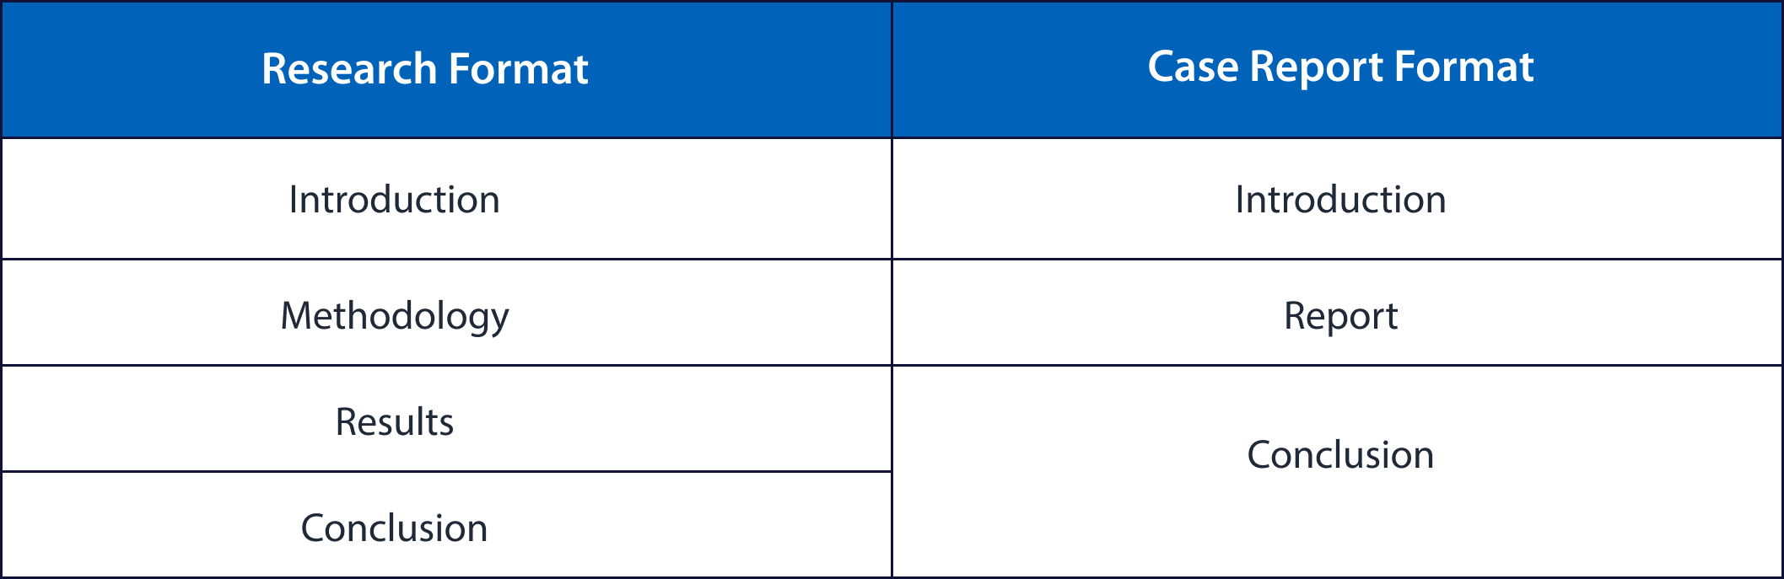
  - Conclusion: Final conclusions drawn from the study.

3.2 ABSTRACT

TITLE | Lorem ipsum dolor sit amet, consectetur adipiscing elit. Pellentesque habitant morbi tristique senectus et netus et malesuada fames ac turpis egestas. Ut interdum, sapien
LIST OF AUTHORS | (Should follow
ABSTRACT | Lorem ipsum dolor sit amet, consectetur adipiscing elit. Pellentesque habitant morbi tristique senectus et netus et malesuada fames ac turpis egestas. Ut interdum, sapien sed pellentesque tincidunt, lectus lorem consequat risus, nec aliquet neque mi ut lacus. Sed id lorem id eros dignissim bibendum. Phasellus convallis nisl non turpis pharetra, vel elementum turpis interdum. Suspendisse potenti. Nulla facilisi. Nam viverra orci ut risus rhoncus, et hendrerit orci dignissim. Curabitur feugiat turpis non risus fringilla, vel vulputate purus blandit. Suspendisse potenti. Duis tristique tincidunt quam at ultrices. Sed posuere libero et ante fermentum, sed suscipit metus volutpat.  Fusce nec tincidunt est, vel molestie purus. Aliquam sit amet lacus nec erat fermentum suscipit id nec enim. Quisque vulputate felis sed enim lacinia, a rutrum velit feugiat. Praesent sit amet luctus arcu. Vivamus vehicula, mi sed euismod varius, nisi neque consequat velit, in sagittis orci est a lorem. Vestibulum lacinia fringilla turpis, nec suscipit purus aliquam eget. Etiam eleifend nulla id ex vulputate, a pretium eros volutpat.  Nullam id nisi sit amet nisl auctor eleifend ut eget ipsum. Proin ut urna ac turpis congue cursus. Mauris ac varius ex, non vestibulum libero. Integer ultricies, risus non commodo accumsan, magna libero suscipit ipsum, eget pharetra purus libero a metus. Etiam interdum metus a quam efficitur dictum. Ut nec ex a nunc lacinia scelerisque. Nunc eget felis nunc. Proin nec libero vel lorem fermentum mollis id a purus.  Praesent fringilla suscipit mi, sed suscipit elit euismod nec. Cras at tortor id eros bibendum laoreet. Duis aliquet, metus quis faucibus pretium, erat lacus finibus lacus, id pharetra erat justo id ligula. Nulla facilisi. Nam sed ex et nulla finibus tincidunt ut sed enim. Suspendisse tincidunt malesuada nisi sed ultrices. Integer vehicula orci eu nisl pharetra, a faucibus mauris tempor. Fusce fermentum scelerisque volutpat.  Sed viverra vestibulum metus in tincidunt. Nulla id orci id nisl fringilla suscipit. Integer non augue eros. Cras ornare risus libero, quis fermentum ligula venenatis ac. Proin ac ligula ut magna tincidunt pharetra. Suspendisse malesuada tellus sit amet tellus feugiat, nec facilisis sapien condimentum. Platea dictumst. Pellentesque ornare erat a justo ultricies consequat.

Image / Graph / Table (1)

Image / Graph / Table (2)

